**east west university**

**Lab Report - 06**

**Department:** **Computer Science and Engineering**

**Course Title:** Digital Image Processing

**Course Code:** CSE438

**Section No:** 02

**Submitted To**:

Dr. Engr. Ahmed Wasif Reza

Associate Professor, Department of Computer Science and Engineering

**Submitted By**:

Name: S M Arafat Rahman

ID: **2019-2-60-094**

1. Apply three types of highpass filtering in the frequency domain on Figure 1;

i. Ideal highpass filter (IHPF).

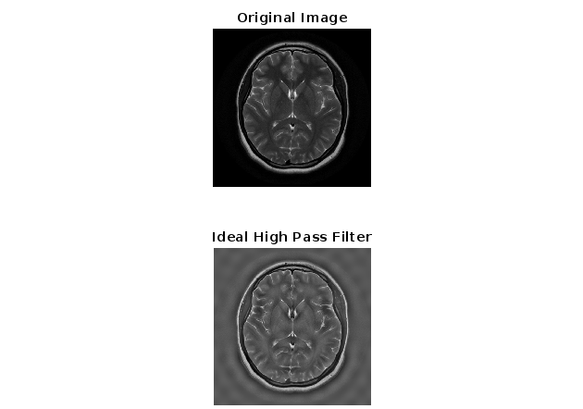

Code:

Fig_1=imread('Brain MRI.png');

[M,N] = size(Fig_1);

FT_Img = fft2(double(Fig_1));

D0 = 10;

u=0:(M-1);

idx=find(u>M/2);

u(idx)=u(idx)-M;

v=0:(N-1);

idy=find(v>N/2);

v(idy)=v(idy)-N;

[V,U]=meshgrid(v,u);

D=sqrt(U.^2+V.^2);

H=double(D>D0);

G=H.*FT_Img;

output_image= real(ifft2(double(G)));

subplot(2, 1, 1), imshow(Fig_1),title('Original Image');

subplot(2, 1, 2), imshow(output_image, [ ]);title('Ideal High Pass Filter');

ii. Butterworth highpass filter (BHPF).

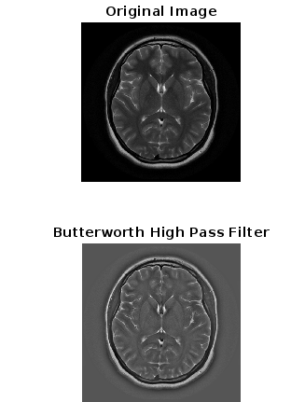

Code:

Fig_1=imread('Brain MRI.png');

[M,N] = size(Fig_1);

FT_Img = fft2(double(Fig_1));

D0 = 10;

u=0:(M-1);

idx=find(u>M/2);

u(idx)=u(idx)-M;

v=0:(N-1);

idy=find(v>N/2);

v(idy)=v(idy)-N;

[V,U]=meshgrid(v,u);

D=sqrt(U.^2+V.^2);

n=2;

H = 1./(1 + (D0./D).^(2*n));

G = H.*FT_Img;

output_image = real(ifft2(double(G)));

subplot(2, 1, 1), imshow(Fig_1),title('Original Image');

subplot(2, 1, 2), imshow(output_image, [ ]);title('Butterworth High Pass Filter');

iii. Gaussian highpass filter (GHPF)

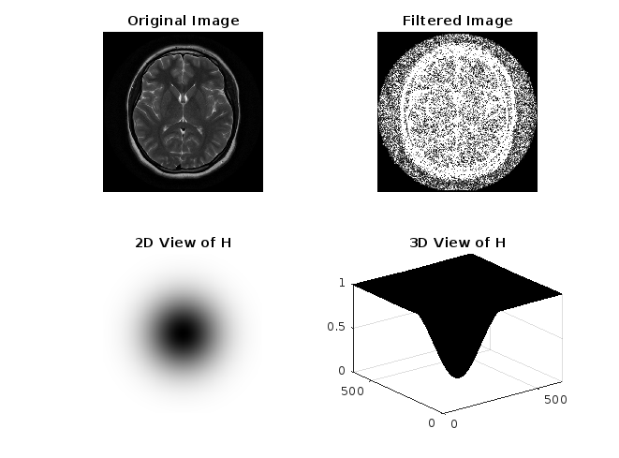

Code:

im = imread('Brain MRI.png');

fc = 100;

imf = fftshift(fft2(im));

[co,ro] = size(im);

cx = round(co/2);

cy = round(ro/2);

H = zeros(co,ro);

for i = 1:co

for j = 1:ro

d=(i-cx).^2+(j-cy).^2;

H(i,j) = exp(-d/2/fc/fc);

end end

H = 1-H;

outf=imf.*H;

out = abs(ifft2(outf));

subplot(2,2,1),imshow(im),title('Original Image');

subplot(2,2,2),imshow(out),title('Filtered Image');

subplot(2,2,3),imshow(H),title('2D View of H');

subplot(2,2,4),surf(H),title('3D View of H');

2. Apply three types of lowpass filtering in the frequency domain on Figure 1;

i. Ideal lowpass filter (ILPF).

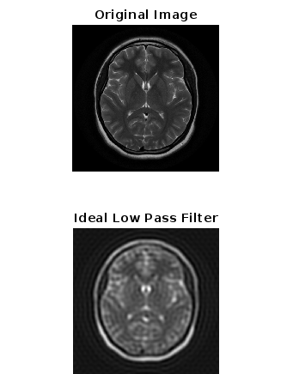

Code:

Fig_1=imread('Brain MRI.png');

[M,N] = size(Fig_1);

FT_Img = fft2(double(Fig_1));

D0 = 30;

u=0:(M-1);

idx=find(u>M/2);

u(idx)=u(idx)-M;

v=0:(N-1);

idy=find(v>N/2);

v(idy)=v(idy)-N;

[V,U]=meshgrid(v,u);

D=sqrt(U.^2+V.^2);

H=double(D<=D0);

G=H.*FT_Img;

output_image= real(ifft2(double(G)));

subplot(2, 1, 1), imshow(Fig_1),title('Original Image');

subplot(2, 1, 2), imshow(output_image, [ ]);title('Ideal Low Pass Filter');

  ii. Butterworth lowpass filter (BLPF)

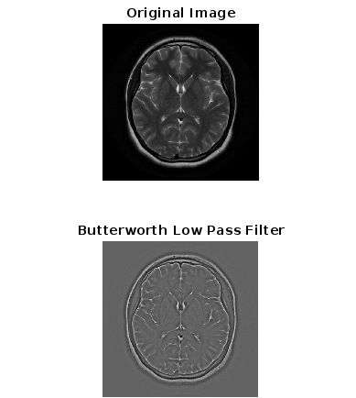

Code:

Fig_1=imread('Brain MRI.png');

[M,N] = size(Fig_1);

FT_Img = fft2(double(Fig_1));

D0 = 20;

u=0:(M-1);

idx=find(u>M/2);

u(idx)=u(idx)-M;

v=0:(N-1);

idy=find(v>N/2);

v(idy)=v(idy)-N;

[V,U]=meshgrid(v,u);

D=sqrt(U.^2+V.^2);

n=2;

H = 1./(1 + (D0./D).^(2*n));

G = H.*FT_Img;

output_image = real(ifft2(double(G)));

subplot(2, 1, 1), imshow(Fig_1),title('Original Image');

subplot(2, 1, 2), imshow(output_image, [ ]);title('Butterworth Low Pass Filter');

iii. Gaussian lowpass filter (GLPF)

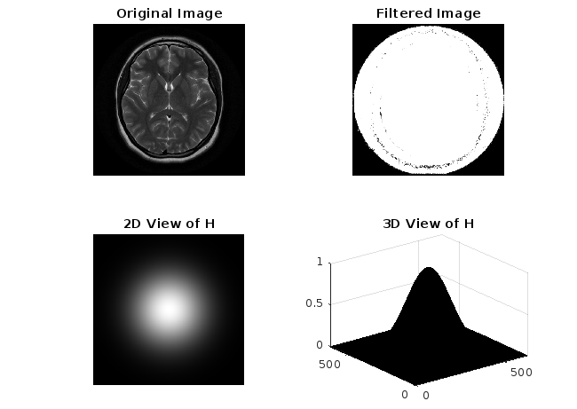

Code:

im = imread('Brain MRI.png');

fc = 100;

imf = fftshift(fft2(im));

[co,ro] = size(im);

cx = round(co/2);

cy = round(ro/2);

H = zeros(co,ro);

for i = 1:co

for j = 1:ro

d=(i-cx).^2+(j-cy).^2;

H(i,j) = exp(-d/2/fc/fc);

end

end

outf=imf.*H;

out = abs(ifft2(outf));

subplot(2,2,1),imshow(im),title('Original Image');

subplot(2,2,2),imshow(out),title('Filtered Image');

subplot(2,2,3),imshow(H),title('2D View of H');

subplot(2,2,4),surf(H),title('3D View of H');

3. Accurate diagnosis is the most vital part of the healthcare sector. For a precise diagnosis, the

test results must display the features as clearly as possible. According to your observations while

solving the previous problems, which filtering technique would you choose if you were given

the task of performing image enhancement on the given image? Explain and justify your reasoning.

**Answer:**

The difference between High pass filtering and Low pass filtering is cut-off frequency. Where the frequency of the signal is higher than the cut-off frequency for the High pass filter. On the other hand, the frequency of the signal is lower than the cut-off frequency for the Low pass filtering.

I would like to use High pass filtering for this scenario because if we use a High pass filter it will sharpen the image. Where a Low pass filter will smooth the image. As we work on the diagnosis. Then when we sharpen the image it will help us to identify the problem a particular problem in a vital situation.

4. Apply Hough transform to Figure 2 and draw the detected lines on the original image.

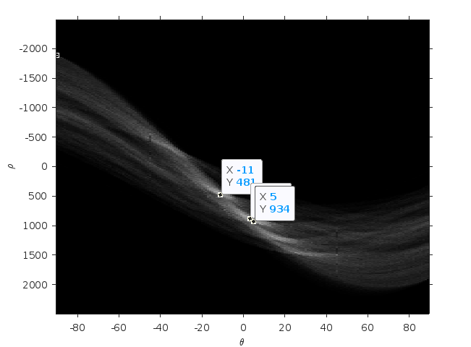

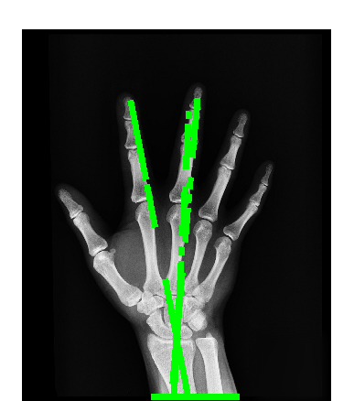

Code:

close all;

k=(imread('X-Ray Image.png'));

m=rgb2gray(k);

imshow(k);

BW = edge(m,'sobel');

imshow(BW);

[H,T,R] = hough(BW);

imshow(H,[],'XData',T,'YData',R,...

'InitialMagnification','fit');

xlabel('\theta'), ylabel('\rho');

axis on, axis normal, hold on;

P = houghpeaks(H,4,'threshold',ceil(0.5*max(H(:))));

x = T(P(:,2)); y = R(P(:,1));

plot(x,y,'s','color','white');

lines = houghlines(BW,T,R,P);

figure, imshow(k), hold on

for k = 1:length(lines)

xy = [lines(k).point1; lines(k).point2];

plot(xy(:,1),xy(:,2),'LineWidth',5,'Color','green');

end